Project Sponsor
The module leadership, who offer academic leadership, resource endorsement, and governance to the project, will sponsor the project and support alignment of the project with institutional learning outcomes, ethical guidelines, and assessment expectations at all stages of the project life cycle.

Project Purpose
This project aims to develop and test an explainable deep learning system to classify brain tumour using MRI images, which will solve the issue of clinical interpretability, trust, and ethical issues of black-box medical AI systems.

Stakeholders
The main stakeholders are the student developers, the module leader and the academic assessors. As end users, clinicians and researchers will be considered secondary stakeholders because patients as indirect beneficiaries will be provided with better diagnostic accuracy and decision-support reliability.

Project Scope (MoSCoW Analysis)
Must: CNN classification, Grad-CAM explainability, evaluation.
Should: Transfer learning, augmentation.
Could: Bias analysis.
Won’t: Clinical deployment or real-time hospital integration.

Project Goals and Objectives (SMART)
In order to design and test an explainable CNN-based MRI tumour classification system in twelve weeks, attain quantifiable performance and interpretability, record reproducible results in GitHub and comply with the principles of responsible and ethical AI.

Success Metrics
The success of the project will be assessed based on accuracy, precision, recall, F1-score, confusion matrices, Grad-CAM visual validation, GitHub commit reproducibility, and academic assessment and learning outcomes.

Assumptions and Constraints
The project presupposes the availability of labelled public MRI data and health information as well as adequate computing capabilities. Limitations are a short length of the project, academic scope, lack of clinical validation, and reliance on secondary data.

Project Milestones (Gantt Overview)
The major milestones will be approval of the proposal, dataset ready, model development, explainability, evaluation, report, GitHub finalisation, and final submission within the identified February-April project schedule. For Gantt Chart please refer in the project proposal.

Roles and Responsibilities (RACI Summary)
The Project Lead will be in charge of delivery, the technical members of the project will be in charge of the implementation, consultations will be done with all the members in the course of reviews, and the module leader will be informed at the end of milestones and final submission.
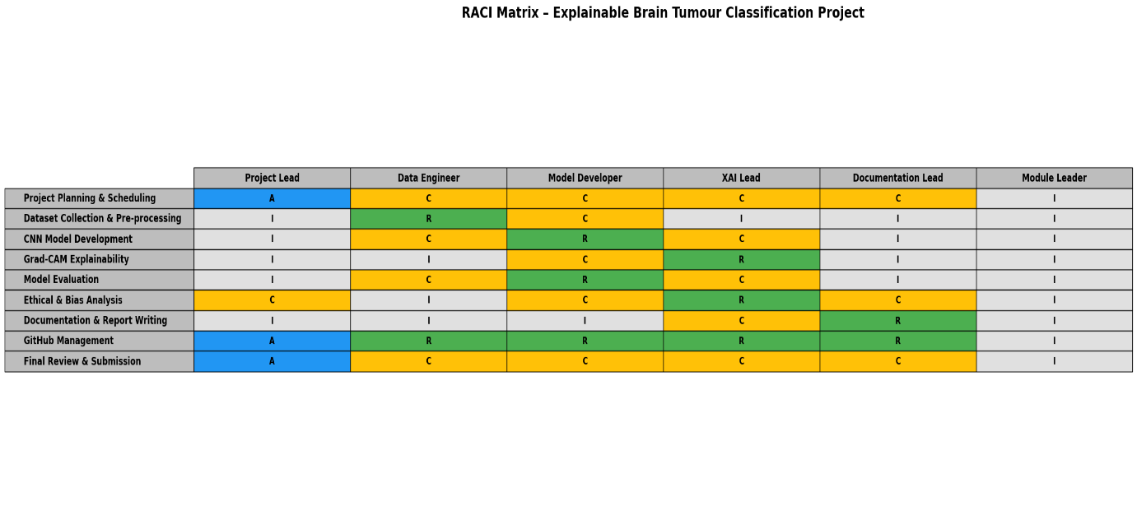
Figure 1 :RACI Summary

Risks (Project-Level)
The possible risks are overfitting of models, poor explainability alignment, bias in the data, time management, and unequal distribution of work, which can be addressed by the means of data augmentation, validation, version control, and frequent team review of the progress.

Approval / Sign-off
Formal approval validates the agreement between the project team and academic supervisor and allows the next project phase to proceed and accept the scope, risks, responsibilities, and specified success criteria.

